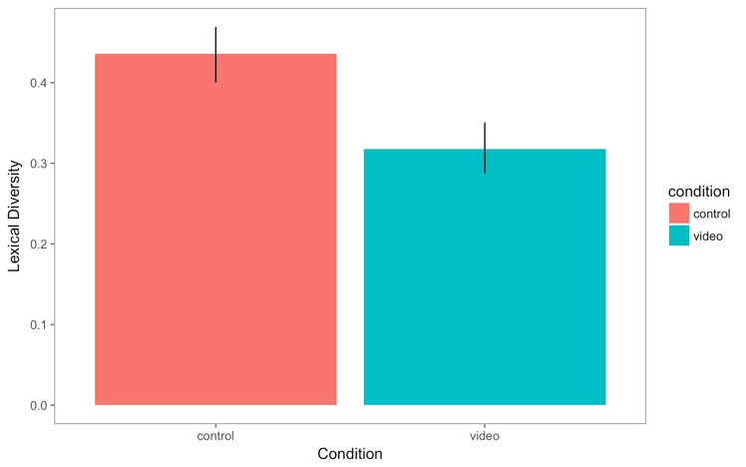

*Figure 1.* Parents engaging in digitally-scaffolded activities produced more word tokens and more bids for joint attention, but had lower lexical diversity (ratio of word types to word tokens) than those who did not watch a video.